**Bioinformatics Report**

**Module 6**

***4624650***

***Anna Paula Pawlicka Maule***

**Exercise 1:**

*Measure the Dn / Ds ratio for CDS's (Coding Sequence) mtDNA of human, mouse and chimpanzee. The identification of sequences in GenBank are NC_012920, NC_005089, NC_001643 respectively.*

***Answer:***

The following results were obtain by aligning the 3 genes using Clustal Omega and running the [SNAP online Tool](https://www.hiv.lanl.gov/content/sequence/SNAP/SNAP.html)

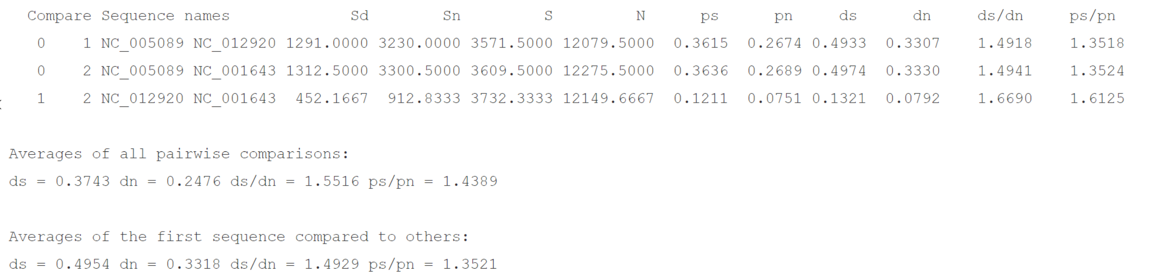

The values for Dn/Ds are:

NC_005089 and NC_012920 : 0.6703831339955402

NC_005089 and NC_001643 : 0.669481302774427

NC_001643 and NC_012920 : 0.5995457986373959

**Dn:** is the average number of nucleotide differences between the sequences per non-synonymous site.

**Ds:** is the average number of nucleotide differences between sequences per synonymous site

A purifying selection (selection against deleterious non-synonymous substitutions) has definitely operated in all 3 genes. Some amino-acid substitutions have been may caused by selection, just not enough to overcome the effects of purifying selection.

**Exercise 2:**   
*Repeat the same exercise, this time using viral genomes (HIV or SARS, discussed in more detail in Chapter 7). Compare the results with those obtained in the exercise 1.*

HIV:

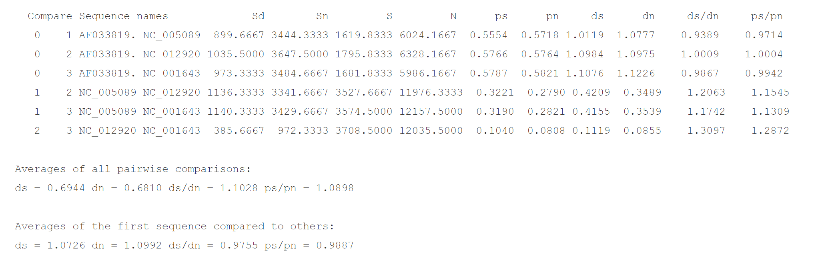

Dn/Ds values:

AF033819 and NC_005089 : 1.065026188358533

AF033819 and NC_001649 : 1.013542795232936

Since the Dn/Ds for the AF033819 and NC_005089, and AF033819 and NC_001649 are greather than 1, it is possible to conclude that the selection has caused some amino-acid substitution for the virus. Some substitutions also have been caused by genetic drift. A purifying selection also likely occurs, but is not strong enough to overcome the effects of the positive selection.

AF033819 and NC_012920 : 0.9991806263656227

A purifying selection has definitely operated at the HIV virus towards the human gene.

SARS:

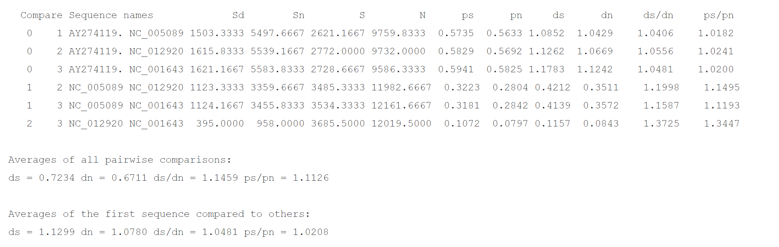

AY274119 and NC_005089: 0.9610210099520826

AY274119 and NC_012920: 0.9473450541644468

AY274119 and NC_001649 : 0.9540863956547569

It is possible to conclude that a purifying selection occurred at the SARS towards all the other 3 genes.